Day 01

Vehicle id: 0

SMAK (0) --> Battaramulla SC (22) --> Wijerama (SCWJ) --> Boralasgomuwa (SCBL) --> Attidiya 02 (SCAD) --> Dehiwala (SCDE) --> Dehiwala SC (23) --> FC MARINE CITY (1484) --> FC DEHIWALA (1106) --> EX DEHIWALA (1774) --> Raththanapitiya (SCRT) --> Borelasgamuwa SS (4) --> Maharagama 2 (SCM3) --> Maharagama 3 (SCMF) --> Maharagama (SCMG) --> Nawinna SC (10) --> Embuldeniya (SCED) --> Thalawathugoda (SCCM) --> Battaramulla (SCBT) --> THALAWATHUGODA (14012) --> FC BIYAGAMA (1548) --> SMAK (0) --> Route Distance: 60km (Max: 120km) Visits: 20 (Max: 20)

Vehicle id: 1

SMAK (0) --> FC BLOEMENDHAL (1555) --> Kotahena 2 (SCK7) --> FC KOTAHENA (1108) --> Kotahena (SCKE) --> EX PORT AUTHORITY (1818) --> FC FORT (1005) --> FC SLAVE ISLAND (1672) --> Crescat (SCCC) --> EX YMCA (1826) --> FC KOLLUPITIYA 02 (1608) --> FC COLPETTY (1105) --> FC GREEN PATH (1661) --> FC BAUDDHALOKA MAWATHA (1676) --> CR FC (14011) --> FC JAWATTA (1419) --> Thimbirigasyaya (SCTB) --> FC PARK ROAD (1109) --> EX NARAHENPITA (1761) --> EX WIJERAMA MAWATHA (1859) --> FC WARD PLACE (1446) --> SMAK (0) --> Route Distance: 41km (Max: 120km) Visits: 20 (Max: 20)

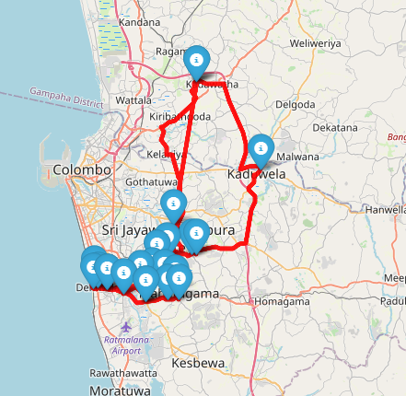

Vehicle id: 0

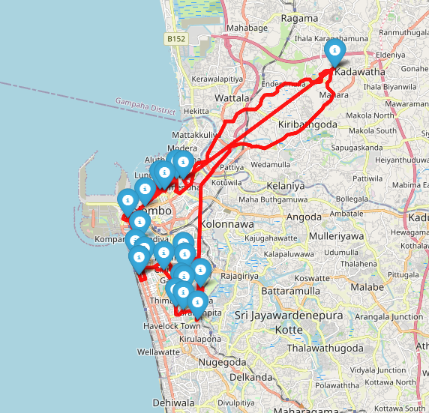

Vehicle id: 1

Vehicle id: 2

SMAK (0) --> EX ASCON RESIDENCE (1728) --> FC DEMATAGODA 02 (1497) --> FC COTA ROAD (1471) --> Rajagiriya 2 (SCRJ) --> Nawala (SCNW) --> NAWALA (14008) --> DELKANDA (14001) --> Kohuwala 2 (SCPY) --> Kohuwala SC (112) --> Delpe (SGRD) --> Kalubowila (SCKL) --> Gamsabha (SCGS) --> Nugegoda 2 (SCNG) --> Pitakotte 2 (SCPO) --> Kohuwala (SCKH) --> Kotte (SCKO) --> Rajagiriya (SCSJ) --> Kotta Road (SCCR) --> EX ROYALPARK (1320) --> EX OVAL VIEW RESIDENCE (1872) --> SMAK (0) --> Route Distance: 44km (Max: 120km) Visits: 20 (Max: 20)

Vehicle id: 3

SMAK (0) --> EX TRILLIUM RESIDENCE (1323) --> EX THIMBIRIGASYAYA (1107) --> EX ISIPATHANA MAWATHA (1888) --> Havelock Road (SCHR) --> EX HAVELOCK ROAD (1305) --> FC DICKMANS ROAD (1291) --> FC JAYA ROAD (1594) --> Marine Drive (SCMD) --> FC MAJESTIC CITY (1033) --> FC MOUNT LAVINIA STC (1130) --> EX BAMBALAPITIYA (1308) --> Duplication Road (SCDP) --> Thurstan (SCTU) --> FC DUPLICATION (1411) --> FC COLOMBO CITY CENTER (1902) --> Hyde Park SC (5) --> FC STAPLES STREET (1017) --> Union Place (SCUP) --> Darley Road (SCDR) --> FC GRANDPASS (1292) --> SMAK (0) --> Route Distance: 37km (Max: 120km) Visits: 20 (Max: 20)

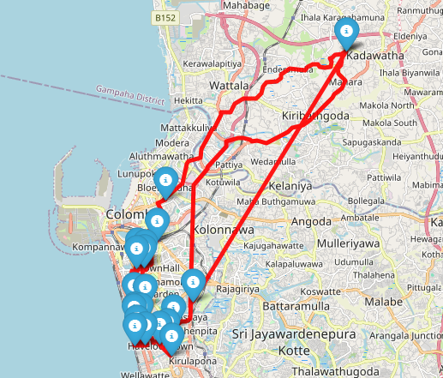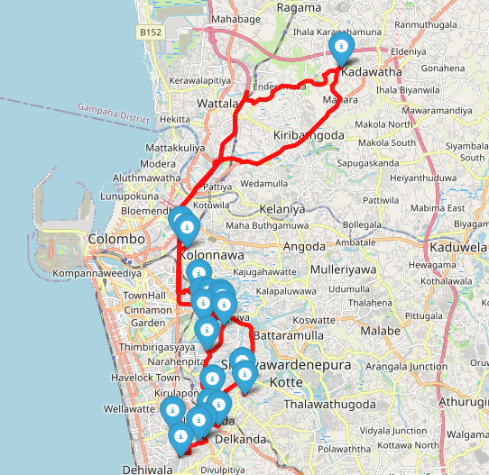

Vehicle id: 3

Vehicle id: 2

Vehicle id: 4

SMAK (0) --> Sinharamulla (SGSM) --> Mulleriyawa -Angoda (SCMU) --> Mulleriyawa Daily (172) --> EX RAHULA JUNCTION (1745) --> Gothatuwa (SCGT) --> Wellampitiya (SCWP) --> FC KOLONNAWA 02 (1614) --> EX DEANS ROAD (1364) --> FC NORRIS CANAL (1433) --> FC MARADANA (1145) --> ASIRI CENTRAL (14003) --> EX ALEXANDRA PLACE (1303) --> Shangri-La Mall (SCSL) --> EX MARADANA 02 (1759) --> FC GLORIOUS RESIDENCE (1545) --> EX MALIGAWATTE2 (1746) --> EX MALIGAWATTE (1301) --> EX MALIGAWATTE 03 (1776) --> EX ORION CITY (1896) --> Kelaniya (SGKY) --> SMAK (0) --> Route Distance: 37km (Max: 120km) Visits: 20 (Max: 20)

Vehicle id: 5

SMAK (0) --> Ganemulla (SGGE) --> Diuwalapitiya (SGDL) --> Minuwangoda (SGMI) --> Minuwangoda SC (123) --> Negombo 2 (SGN2) --> NEGOMBO (14007) --> Dalupotha (SGND) --> Negombo SC (26) --> Negombo Kurana (SGNK) --> Seeduwa SC (128) --> Seeduwa (SGSE) --> Kochchikade (SGKC) --> FC WATTALA (1084) --> Ja Ella (SGJA) --> Negombo Telwatta (SGNO) --> JA Ela 3 (SGJW) --> KANDANA (14013) --> Kandana Daily (171) --> FC MUTUWAL (1137) --> Mattakuliya (SCMY) --> SMAK (0) --> Route Distance: 90km (Max: 120km) Visits: 20 (Max: 20)

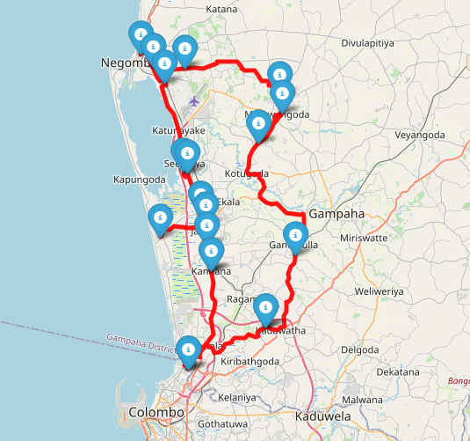

Vehicle id: 5

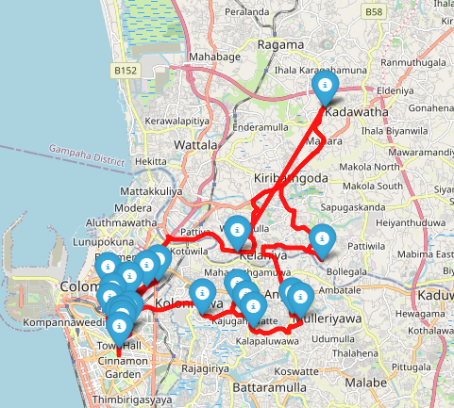

Vehicle id: 4

Vehicle id: 6

SMAK (0) --> Mawaramandiya (SGMQ) --> EX MALWANA (1338) --> EX ERIYAGAMA (1355) --> FC BOMIRIYA (1549) --> Akuregoda (SCAK) --> Vidyala Junction (SCVJ) --> Hokandara (SCHD) --> Thalawathugoda 3 (SCTL) --> Pitakotte (SCPK) --> Thalawathugoda SC (116) --> Thalawathugoda 2 (SCTG) --> Arangala (SCAR) --> Pittugala (SCPT) --> Thalahena (SCTH) --> Biyagama (SCBI) --> Mawanella (SLMN) --> Malabe SS (110) --> MALABE (14010) --> FC KOTHALAWALA (1678) --> Kaduwela (SCKX) --> SMAK (0) --> Route Distance: 56km (Max: 120km) Visits: 20 (Max: 20)

Vehicle id: 7

SMAK (0) --> Enderamulla (SGEM) --> Kiribathgoda 2 (SGKG) --> Kiribathgoda (SGKB) --> Kiribathgoda SS (14) --> Tyre Junction (SGTY) --> Kerawalapitiya (SGKR) --> Wattala 2 (SGWA) --> WATTALA (14015) --> Wattala-2 ADA (117) --> Wattala SC (3) --> Welisara (SGMH) --> Ragama (SGRA) --> Ragama Daily (150) --> Eldeniya (SGEL) --> Kirillawala (SGK5) --> Weliweriya Daily (156) --> Miriswatta (SGMP) --> Gampaha 2 (SGGP) --> Gampaha SC (24) --> Yakkala (SGYK) --> SMAK (0) --> Route Distance: 55km (Max: 120km) Visits: 20 (Max: 20)

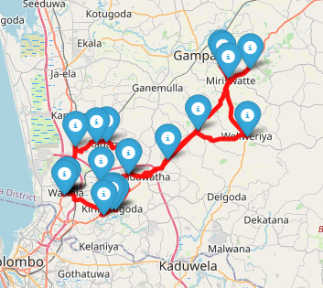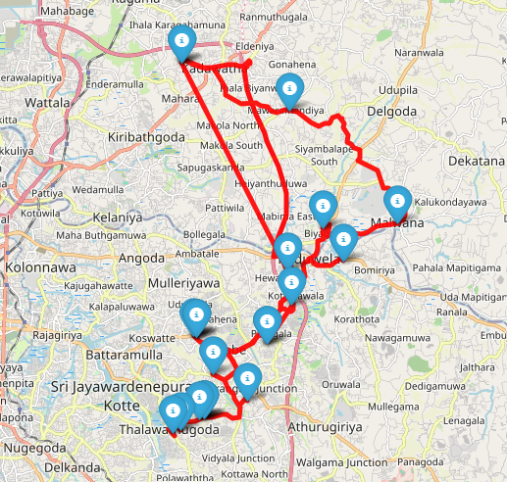Total distance for all vehicles: 420km

Vehicle id: 7

Vehicle id: 6

Day 02

Vehicle id: 0

SMAK (0) --> FC W. A. SILVA MAWATHA (1650) --> Wellawatte SS (25) --> Mount Lavinia (SCML) --> Moratuwa 3 (SCMW) --> Gorakana (SIGN) --> Panadura SC (106) --> Panadura 03 (SIP4) --> Kaluthara 2 (SIWK) --> Katukurunda SC (127) --> FC ALUTHGAMA 02 (1589) --> Aluthgama (SIAL) --> Beruwala (SIBE) --> FC BERUWELA (1115) --> EX MAGGONA (1727) --> Kaluthara (SIKS) --> Kalutara SS (79) --> Horana (SIHZ) --> EX RAIGAMA (1836) --> SMAK (0) --> Route Distance: 149km (Max: 250km) Visits: 18 (Max: 18)

Vehicle id: 1

SMAK (0) --> FC MATHUGAMA (1475) --> FC MATHUGAMA 02 (1670) --> EX PITIGALA (1797) --> EX ELPITIYA (1768) --> EX KARANDENIYA (1349) --> FC AMBALANGODA (1117) --> FC AMBALANGODA2 (1466) --> Ambalangoda Daily (163) --> Ambalangoda (SFAB) --> EX AHUNGALLA (1781) --> Wadduwa (SIWD) --> Nalluruwa (SINL) --> Panadura 2 (SIP2) --> EX BENTOTA (1331) --> FC ALUTHGAMA (1114) --> FC DHARGA TOWN (1286) --> EX SOUTHERN HIGHWAY B (1353) --> EX SOUTHERN HIGHWAY A (1352) --> SMAK (0) --> Route Distance: 230km (Max: 250km) Visits: 18 (Max: 18)

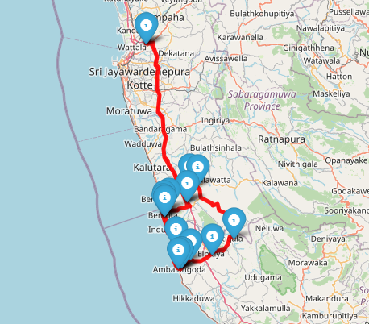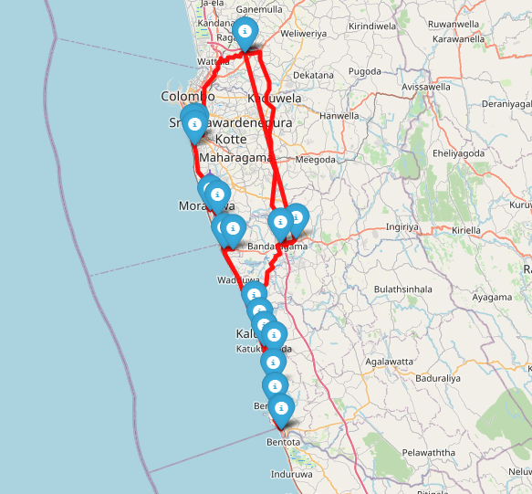

Vehicle id: 1

Vehicle id: 0

Vehicle id: 2

SMAK (0) --> Yakkala SS (114) --> FC NUWARA ELIYA (1020) --> FC KEGALLE (1111) --> FC KIRIBATHKUMBURA (1663) --> EX GALAHA ROAD (1600) --> FC GATAMBE (1467) --> ASIRI KANDY (14004) --> EX GELIOYA (1360) --> KANDY - MCC (14014) --> Kandy 3 (SKKI) --> Kandy 2 (SKK2) --> FC NAWALAPITIYA (1289) --> FC PILIMATALAWA (1157) --> FC PILIMATHALAWA 02 (1592) --> FC MAWANELLA (1199) --> Kegall (SLKV) --> Kegalle SC (115) --> EX ALAWWA (1324) --> SMAK (0) --> Route Distance: 199km (Max: 250km) Visits: 18 (Max: 18)

Vehicle id: 3

SMAK (0) --> Kochchikade SC (119) --> Wennappuwa (SPWN) --> Wennapuwa Daily (167) --> Maravila (SPMV) --> Chilaw (SPCH) --> Chilaw Daily (174) --> FC WARIYAPOLA (1428) --> EX YANTHAMPALAWA (1844) --> Kurunegala 02 (SNRU) --> Kurunegala SC (111) --> KURUNEGALA (14005) --> EX MALKADUWAWA (1735) --> EX PIDURUWELLA (1845) --> FC NARAMMALA (1490) --> Kuliyapitiya Daily (161) --> FC KULIYAPITIYA (1278) --> FC KULIYAPITIYA 02 (1619) --> FC PANNALA (1281) --> SMAK (0) --> Route Distance: 256km (Max: 300km) Visits: 18 (Max: 18)

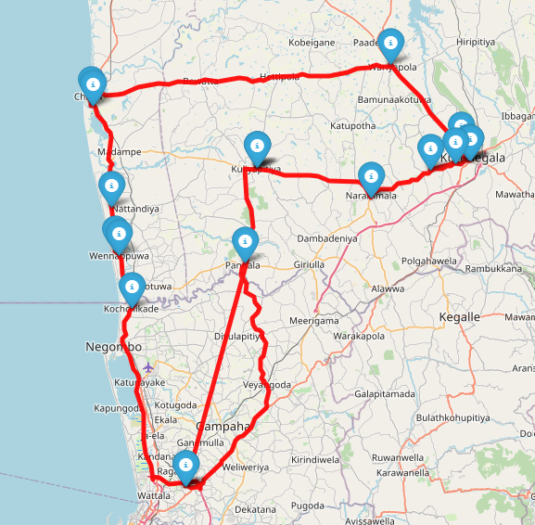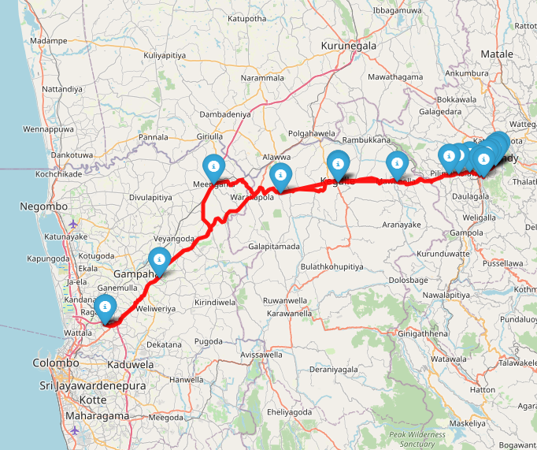

Vehicle id: 2

Vehicle id: 3

Vehicle id: 4

SMAK (0) --> Avissawella (SCAV) --> FC PALMADULLA (1412) --> Ehaliyagoda (SREG) --> FC EHELIYAGODA (1186) --> EX KURUWITA (1321) --> FC RATNAPURA (1104) --> Rathnapura Main Arpico Daily (188) --> FC BANDARAGAMA (1279) --> Rathnapura (SRRP) --> FC RATNAPURA 03 (1546) --> Rathnapura 2 (SRRR) --> Pelmadulla Arpico Daily (191) --> FC BALANGODA (1139) --> EX PALLEBEDDA (1801) --> EX GODAKAWELA (1368) --> FC RATHNAPURA 02 (1576) --> Watareka Daily (181) --> EX WATAREKA (1840) --> SMAK (0) --> Route Distance: 287km (Max: 300km) Visits: 18 (Max: 18)

Vehicle id: 5

SMAK (0) --> Pannipitiya (SCPN) --> Kottawa SS (108) --> Kottawa 3 (SCK3) --> KOTTAWA (14006) --> EX MABULGODA (1892) --> EX MAKULUDUWA (1739) --> Kesbewa (SCKZ) --> Kesbewa 2 (SCKJ) --> Piliyandala SS (76) --> Piliyandala 2 (SCPA) --> Piliyandala (SCPI) --> EX SUWARAPOLA (1327) --> katubedda (SCK6) --> Moratuwa Mall (SCM2) --> Rathmalana (SCRM) --> Aththiditya Daily (168) --> MOUNT - LAVINIA (14009) --> Edmonton (SCET) --> SMAK (0) --> Route Distance: 70km (Max: 300km) Visits: 18 (Max: 18)

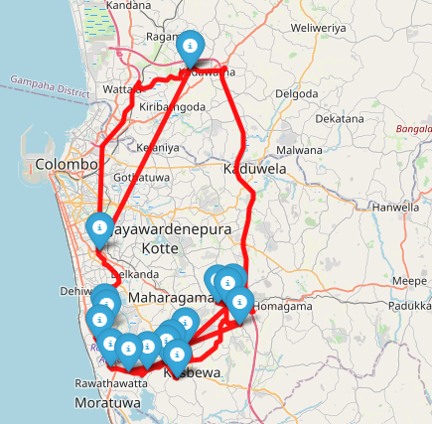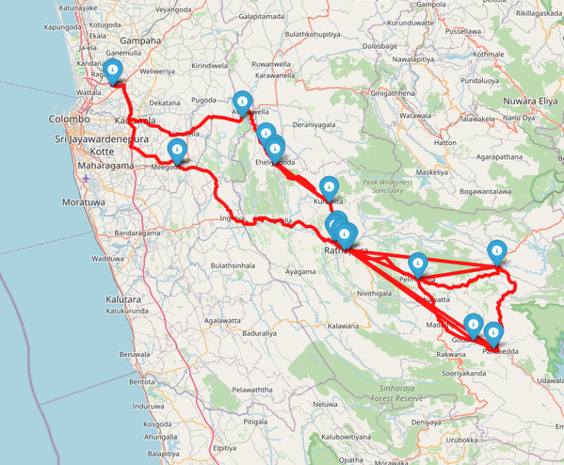

Vehicle id: 4

Vehicle id: 5

Vehicle id: 6

SMAK (0) --> Homagama (SCHG) --> Homagama SC (113) --> Godagama (SCGO) --> EX NAWAGAMUWA (1762) --> Athurugiriya Daily (152) --> Athurugiriya 2 (SCA2) --> FC AVISSAWELLA 02 (1667) --> FC AVISSAWELLA (1116) --> EX THALDUUWA (1760) --> EX DERANIYAGALA (1372) --> EX YATIYANTOTA (1825) --> EX BULATHKOHUPITIYA (1802) --> EX KOTIYAKUBURA (1326) --> EX KANNATHTHOTA (1854) --> EX RUWANWELLA (1322) --> SMAK (0) --> Route Distance: 187km (Max: 400km) Visits: 15 (Max: 15)

Vehicle id: 7

SMAK (0) --> Thihariya (SGTI) --> FC WARAKAPOLA (1133) --> EX ALAWWA 02 (1810) --> FC PUTTALUM (1443) --> EX POTHUHERA (1887) --> FC KURUNEGALA 03 (1498) --> FC KURUNEGALA 04 (1680) --> Kurunegala 03 (SNRN) --> FC KURUNEGALA (1076) --> EX IBBAGAMUWA 02 (1791) --> EX IBBAGAMUWA (1377) --> FC MAWATHAGAMA (1671) --> EX RAMBUKKANA (1386) --> FC RAMBUKKANA (1597) --> FC KEGALLE 02 (1567) --> SMAK (0) --> Route Distance: 196km (Max: 400km) Visits: 15 (Max: 15)

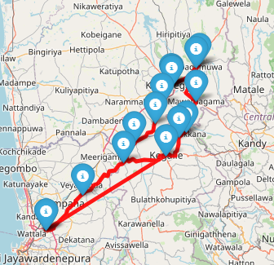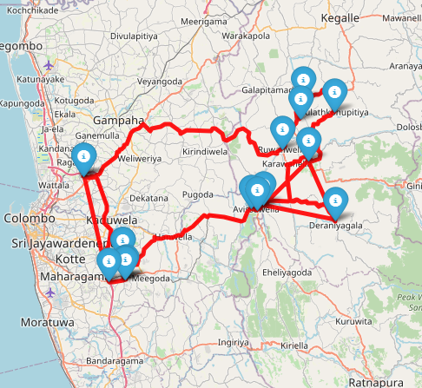Total distance for all vehicles: 1574

Vehicle id: 7

Vehicle id: 6